

|  |
| --- |
| [Version 2.0]  **Last saved by: Ben McGregor**  **Last saved on:** 7/12/2014 |

|  |
| --- |
| Iteration 5 Plan Update |
| [Publish Date] |
| **Charlotte Hutchinson**  CO600: JustHealth Supervisor: Yang He |

JustHealth Iteration 5 Plan Update

On the 1st December 14, we decided at a group that we had over estimated the amount of time adding, editing and deleting medication and appointments would take for both carers and patients, in web and android. Therefore, we have made a decision to focus on adding medication and appointments for iteration 5, editing and deleting appointments and medication for iteration 6 and move back notifications and reminders to iteration 7 replacing what it currently already in iteration 7. These changes can be reflected in Gantt Chart version 6.7

Since the test cases were written at the start of iteration 5, we have moved all the test cases for notifications and reminders to iteration 6 test cases.

At the end of iteration 6, as a group, we will review all off next terms requirements and re structure the plan for iteration 7 onwards.

Revised iteration plan:

# Aims:

* To have a fully functioning way for carers to add medication details for patients.
* A secure and safe way to add medication details for patients to avoid human error
* For carers and patients to be able to add appointment details.
* The Android app to be integrated with the phones Google calendar.

# Requirements:

## 2.1 Functional requirements:

1. The ability for a carer to be able to enter in medication details for a patient- Web
2. The ability for a carer to be able to enter in medication details for a patient- Android
3. The ability for a patient or carer to enter appointment details- Web
4. The ability for a patient or carer to enter appointment details- Android
5. Linking with the android built in calendar

## 2.2 Non-functional requirements:

1. User Documentation
2. Security
   1. Ensuring only certain people can enter medication details
   2. A safe way for people to enter medication and unable to make human errors
   3. Secure ways of dealing with push notifications
   4. Safe connection with the android calendar
3. Robustness
   1. Error handling
   2. Security (as above)
4. Ease of Use
   1. Simple and intuitive design
   2. Clear colour scheme
   3. Clear and easy way for both patients and users to enter information

## 2.3 Domain Requirements:

1. Security (Android)
   1. Ensuring a user understands the connection with their phone calendar
   2. The app can only link with the google calendar rather than third party ones
2. Push notifications in Android linking with the google cloud
3. Legal
   1. Only correct medication can be entered, ensures validations on fields to prevent human error.
   2. Confirmation screen when medication has been entered

# Design

## 3.1 Android appointment design:

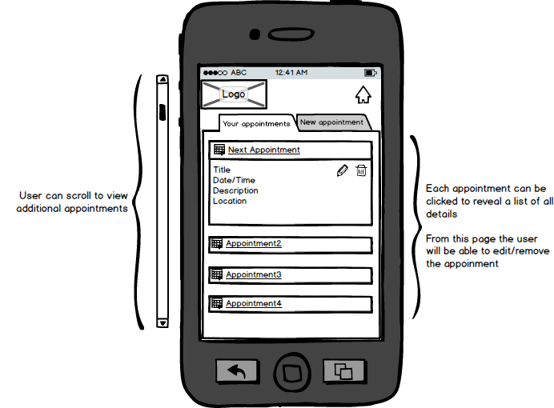

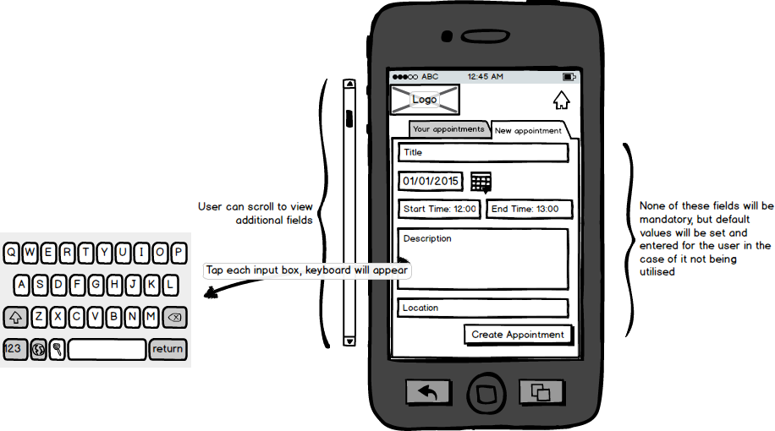

## 3.2 Web appointment design:

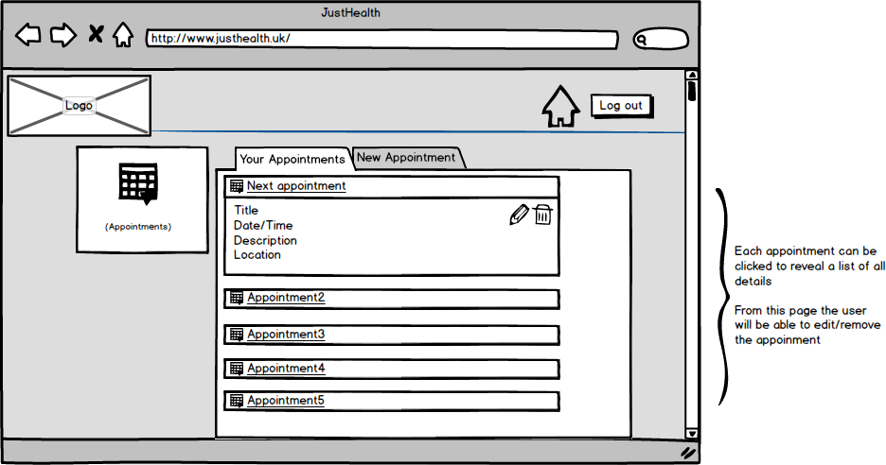

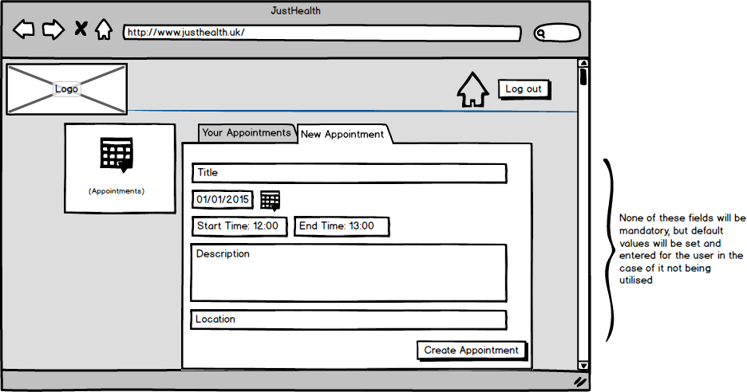

## 3.3 Android medication design

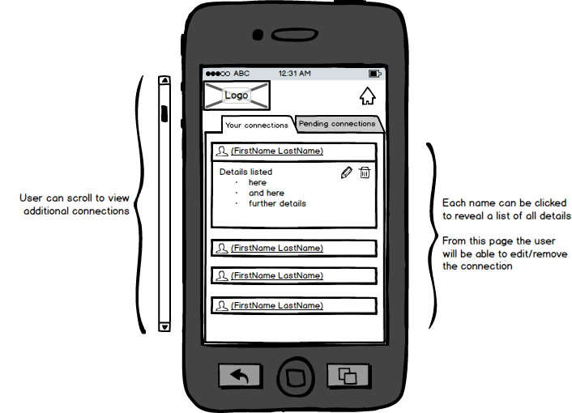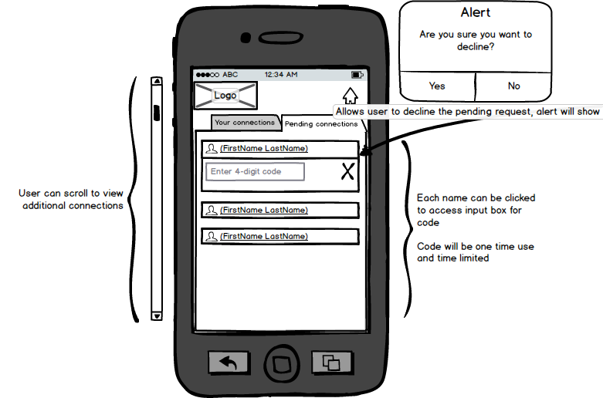

## 3.4 Web medication design

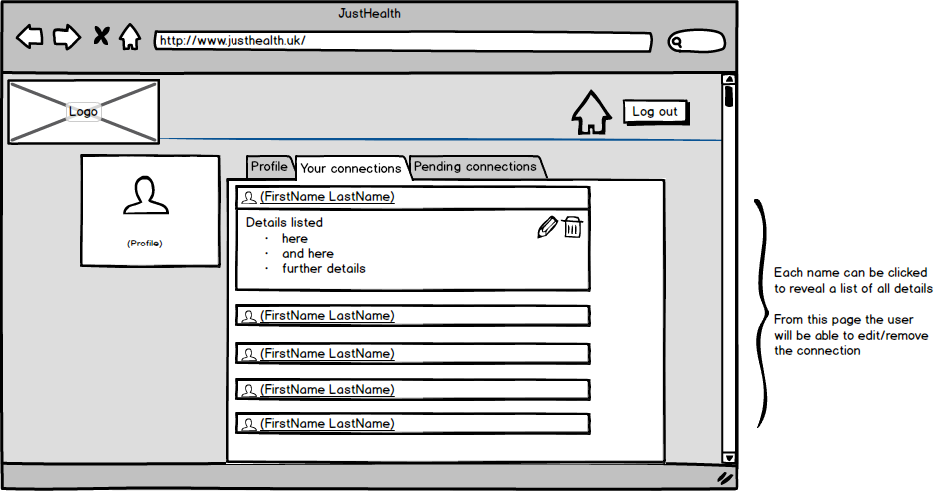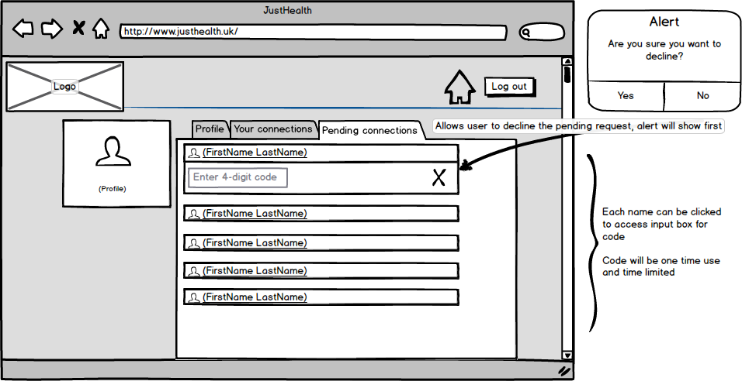

# 4.0 Use cases:

